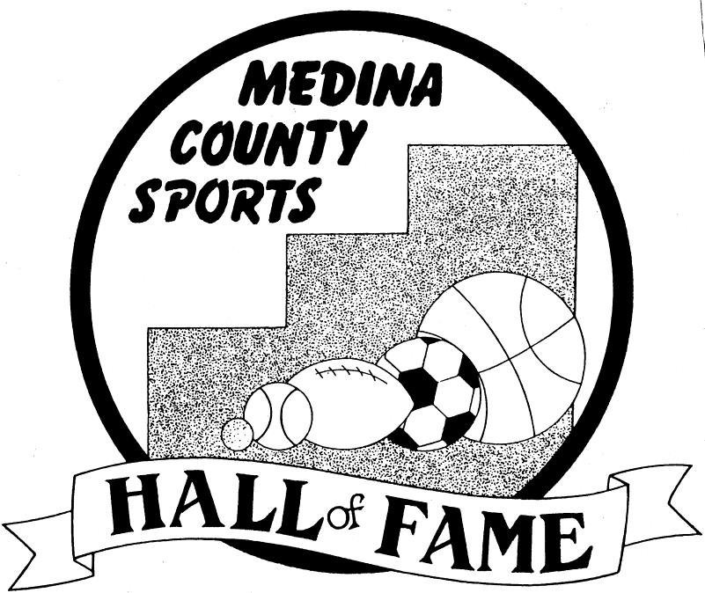

**39th ANNUAL**

**Induction and Recognition of ALL-GAZETTE TEAMS**

**Friday June 14, 2024**

**THE GALAXY CONFERENCE CENTER**



### MASTER OF CEREMONIES

**Inductee Program**

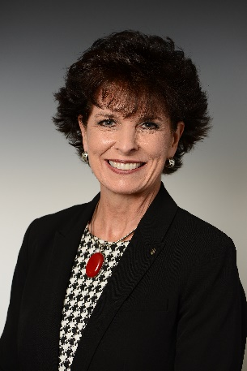

**Mayor Robin Laubaugh**

Our induction ceremony MC is Robin Laubaugh, who is serving her fifth term as mayor of the City of Wadsworth.  Prior to becoming mayor in 2008, Robin served on Wadsworth City Council for 10 years as council at-large and later, as president of council. She is Wadsworth’s longest-serving mayor (16 years) and the first female mayor.

Between city meetings, Mayor Laubaugh is busy attending various community events, meetings with residents, businesses, officials or representatives throughout the county, attending sporting events and other key functions.

We are pleased to have Mayor Laubaugh with us tonight. She has been a strong advocate for sports in Wadsworth. Many improvements to sports facilities have been put in place because of her support as mayor of Wadsworth.

### 2024 MEDINA COUNTY SPORTS HALL OF FAME

***INDUCTEE***

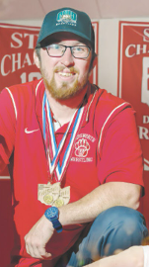

**Brad Squire**

**Wrestler**

A 2010 Wadsworth graduate, Squire helped lead the Grizzlies to a Division I state team championship as a senior. His 3-2 decision over St. Edward’s Anthony Salupo at 145 pounds helped the Grizzlies end a 13-year championship streak by the Eagles and become the first public school to win the big-school division since 1977. As a freshman, Squire defeated Lakota West’s Ryan Fields 2-0 in overtime to win the 119-pound state title. Before wrestling for Ohio University, he compiled 144 victories in high school, won the 130-pound Ironman national championship as a sophomore and was a three-time state finalist and four-time state placer.

### 2024 MEDINA COUNTY SPORTS HALL OF FAME

***INDUCTEE***

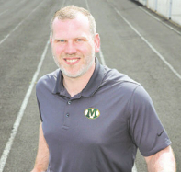**2024 MEDINA COUNTY**

**SPORTS HALL OF FAME**

***INDUCTEE***

**Frank Shotwell**

**Track and field**

A 2006 Medina graduate, Shotwell finished second in the 300-meter hurdles and third in the 110 hurdles at the Division I state track and field meet en route to earning Gazette MVP honors as a senior. He was fifth in the 300s as a junior. At Michigan, Shotwell set school records in the decathlon and heptathlon. He won the Big Ten outdoor championship in the decathlon as a sophomore, helping the Wolverines to the conference team title. Named 2010 National Strength & Conditioning Association Athlete of the Year, he lives in Medina with wife Liz and works as a national account manager for the J.M. Smucker Company.

**Ethan Dunbar**

**Tennis**

A 2010 Cloverleaf graduate, Dunbar was a four-time Gazette

MVP in boys tennis and set a Medina County record for wins

with 120. He was a four-time Suburban League champion at

first singles, never lost a regular-season match and finished

fourth at the Division I state tournament as a senior. At

Richmond, Dunbar was a first-team All-Atlantic 10 Conference selection for four straight years and compiled the third-most

wins in program history. He played professionally for two years, currently lives in Copley Township and works as the chief investment officer for Revisor, an investment management

firm in Fairlawn.

### 2024 MEDINA COUNTY SPORTS HALL OF FAME

***INDUCTEE***

**Becca Candler**

**Soccer**

The high-scoring forward led the Medina girls soccer team to the 2009 Division I state championship en route to earning Gazette MVP honors as a senior. Candler went on to star at Indiana University, where she helped the Hoosiers reach the second round of the NCAA Tournament as a senior. Candler then played professionally for a brief time with the Seattle Reign, where her teammates included Olympic gold medal winners Hope Solo and Megan Rapinoe. She and husband Cheney Dale live in Houston and have two daughters, Sloane, 3, and Elowen, 1. Candler works as a commercial real estate consultant for Deloitte.

### 2024 MEDINA COUNTY SPORTS HALL OF FAME

***INDUCTEE***

**Tyler Houska**

**Football, Wrestling**

A 2009 Highland graduate who earned four letters in both wrestling and football, Houska won a Division II state title at 215 pounds as a senior and was second as a junior. He helped the football team reach the 2008 regional finals, where the Hornets fell 28-21 to eventual state champion Sylvania Southview. Houska also lettered in both sports for four years at Ashland University, reaching the D-II National Championships as a heavyweight wrestler and helping the Eagles capture a league title and qualify for the playoffs in football. Married to high school sweetheart Carly and the father of four, Houska works as the office manager for Akron-based Medical Resources, which manufactures custom orthotics.

### 2024 MEDINA COUNTY SPORTS HALL OF FAME

***INDUCTEE***

**Jeff Miller**

**Al Thomas Award**

**The Al Thomas Award is presented to a Medina County community member who has been involved with and supported athletic programs.**

A 1996 Highland graduate who did not play sports in high school, no one attends more Hornets athletic events and donates more time than the 46-year-old Miller. He has kept the scorebook for the girls soccer team since 1994 and for the boys team since 2011. Miller also runs the clock for the girls basketball and boys and girls lacrosse teams and does whatever is necessary at boys basketball home games. In addition, he does most of the ordering and stocking for the concession stands at various athletic events. Miller has worked as a bus driver in the Buckeye school system for 16 years, the last 13 as a full-time employee.

# 2024 SPECIAL TEAM RECOGNITION

**2010 Division I State runner-up  
Medina Boys cross country team**

###### Sponsored by Jeri and Alan Penn

Led by legendary coach Milt Place, the Bees placed second at the Division I state meet, finishing one point behind Louisville for the team title. Inspired by the championship-winning 2007 Medina team, seniors David Knack, Kevin Paradise, Alex Fotheringham and Brent Gaither led Medina on a dominant campaign to try to repeat the feat. With the contributions of juniors Brad Palocko and Robert Robinson and sophomore Tommy Menyes, the Bees won the Northeast Ohio Conference Valley Division, Lorain County Community College District and Tiffin Regional.

**2024 MEDINA COUNTY**

**SPORTS HALL OF FAME**

***INDUCTEE***

**Chris Hassinger**

**Kiwanis Joe Tait Legacy Award**

##### This award was developed because our Kiwanis Club believes that we need to recognize coaches, teachers and others involved in community-based or school-based teams that have had a positive impact on the lives of the athletes they coached and the community in which they coached.

Coach Hassinger graduated from Wadsworth High School, where he played basketball and baseball. He went on to play four years of basketball at Wayne College, where he earned his master’s degree in physical education.

His coaching career started in 1994 at Claggett Middle School, followed by A.I. Root Middle School and the high school as JV coach/assistant varsity coach.

He was head girls coach for four years, compiling a 63-26 record, and has been head boys coach for 10 years with a record of 159-94 with a Medina County-record four district championships and one regional runner-up.

While being successful on the floor as a coach, Hassinger is most proud of his team’s successes off the court. He has instilled in his players the desire to give back to their community through service to others.

Coach Hassinger uses three key words when talking to his team. They are: **Relationships** — the way in which two or more people are connected or the way they behave towards each other.

**Serve** — perform duties or services for others.

**Legacy** — legacy may come from one’s character, reputation and/or from the life you lead, setting an example for others to guide their futures.

**Some of Coach Hassinger community engagement activities with his teams are:**

He developed a basketball mentorship — All the principals and counselors have his contact information if they have a struggling student(s) that are linked with one of his teams. He has his players read to elementary students

He conducts free basketball clinics at low-income areas and hands out free pizza and basketballs.

With his players, he developed the Santa Project. They buy, wrap and deliver Christmas gifts for kids in low-income areas. His teams also provide a Christmas meal for the family.

Team members provide community service for seniors and sick people who need help around their house.

He sets up visits for elderly fans who are shut in and cannot attend games.

His teams support athletes at Special Olympics games. His teams hold scrimmages and practices with Empower Sports for players with special needs

.

Team members attend funerals of special fans and alumni to show support.

He sends baskets and flowers to opposing teams when there is a tragedy that impacts their team.

He brings his team members to Feeding Medina County to assist with handing out food.

He has been married to his wife Hilary for 28 years. They have four children — Drew, Hayden, Luke and Reese.

**The Gazette  
& The Medina Breakfast Kiwanis Club**

**Welcomes you**

**The Medina Breakfast Kiwanis Club and The Gazette established the Medina County Sports Hall of Fame in 1985. This is the 39th banquet and induction ceremony.**

**The hall of fame honors amateur and professional athletes from Medina County who have excelled in competition, been out of high school for at least 10 years and have lived in the county for at least five years. Inductees will have plaques displayed on our wall of fame located in the Medina Community Recreation Center.**

**Athletes who have been selected as members of the All-Gazette teams, the coaches and MVPs of those teams and The Gazette Senior Athletes of the Year are being recognized. The Fall, Winter and Spring Coaches of the Year will be honored, too.**

**Athletes of the year from Special Olympics are also being recognized.**

**The Kiwanis Joe Tait Legacy Award recognizes a coach/person who isn’t simply interested in their win/loss record but encourages their players to become involved in their community by volunteering and doing charity work. We will recognize coaches or volunteers of both community-based teams or school-based teams.**

**We would like to acknowledge the generosity of our sponsoring individuals and companies for this year and the past 39 years. We hope you will enjoy this evening and share in the success of the athletes.**

##### Chet Simmons, President Medina Breakfast Kiwanis Club

**Albert Grindle, Sports Editor The Gazette**

**Program**

##### Welcome Chet Simmons, President Medina Breakfast Kiwanis

**Pledge of Allegiance , Past President**

**Medina Breakfast Kiwanis**

**Invocation Roy Lehman, Chair, Medina County Sports Hall of Fame**

**Dinner**

**Awards presentation**

**Introductions Tom Borror, Past President**

**Medina Breakfast Kiwanis**

**Master of ceremonies Wadsworth Mayor Robin Laubaugh Kiwanis Joe Tait Legacy Award**

**Special team recognition**

**Presentation of the Special Olympics Athletes of the Year Clay Benjamin Baseball Scholarship**

**Hall of fame Induction ceremony**

**All-Gazette teams, MVPs and coaches of the year Rick Noland**

**Gazette Sports Presentation of Gazette Senior Athletes of the Year**

**Closing Comments Tom Borror**

**Medina Breakfast Kiwanis**

**Medina County Sports Hall of Fame**

**(Sponsor Form)**

(Please give us your name and address so we can thank you!)

Name _________________________________________________

Address___________________________________________

City _______________________________________ State _____________ Zip________________________

Email________________________________________Phone__________________

**Choose your level of Sponsorship**

_____Patron/Sponsor Ad $75 – **Name listed only**

_____Past Inductee Sponsor Ad $75 – **Name listed only**

_____Block Ad $150 – **Please forward ad copy**

_____Double Block Ad $300 – **Please forward ad copy**

_____Team Sponsor $750-$1,500 – **Please pick team**

_____Gold Level Sponsor $1,000

_____Platinum Level Sponsor $2,000

_____Anonymous Sponsor – _______________ Your Donation Amount ________

Amount Enclosed $______________________

Please remit by email or mail to: The Medina Kiwanis Breakfast Club Foundation

**3593 Medina Rd #115**

**Medina, OH 44256**

If you would like to pay online with a credit card go to www.medinacountysportshof.org, click on the sponsor button to make your sponsorship level selection.

Be sure to email this form to roy_lehman@yahoo.com or mail the form to the address above.

The Medina Breakfast Kiwanis Club Foundation is a sub-fund of the Ohio District Kiwanis Foundation, a 501c3 nonprofit organization. All donations will be used to support community service and charity projects of the Medina Breakfast Kiwanis Club.

Thank you for your support of our Medina County Sports Hall of Fame.

For more information, contact Roy Lehman at roy_lehman@yahoo.com or www.medinacountysportshof.org.

**Special Thank You**

The Medina Breakfast Kiwanis Club and The Gazette wish to thank our event sponsors for helping us celebrate 39 years of our Medina County Sports Hall of Fame. Each sponsor is listed in the program or in our special hall of fame section in The Gazette. Be sure to thank them for their continued support of the finest recognition program for athletes in Medina County.

## Platinum Level Sponsors

##### ($2000 and above)

**Galaxy Conference Center and Restaurant**

**Robert and Beverly Acord**

**Sharon and Tom Borror**

**Gold Level Sponsors**

**($1000 and above)**

**Roy and Aileen Lehman**

**Jeri and Alan Penn**

**Stonegate & 3XL Self Storage, LLC**

**Serpentini of Medina**

**George M. Brown**

**Past Inductee Sponsors**

New this year is the addition of an event sponsorship by

past inductees. We want to thank the following past

Medina County Sports Hall of Fame inductees for their

support of this year’s inductees and All-Gazette athletes

and coaches.

**Jeanne Pritchard**

**Jim Wienczkowski**

**Leo Sparr**

**Karen Kase**

**Jerry Gunner**

**Ken Rockhold**

**Patty and Glen Reisner**

**Dr. Michael Carlson**

**John Coyne**

**Dr. Jim Kendel**

**Joe Lazor**

**Bill Schnurr**

**Jan Simmons**

**Carl Abell**

**Frank Shotwell**

**Tony Stockman**

**Jim Demo**

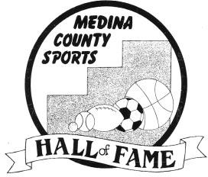

**Hall of Fame Selection Committee**

The Gazette and the Medina Breakfast Kiwanis Club wish to express our appreciation to those who have assisted in our hall of fame selections.

Roy Lehman, chairman, Medina Breakfast Kiwanis Club

Albert Grindle, sports editor, The Gazette

Rick Noland, The Gazette

John Urchek, The Gazette

Rob Clarico, Black River athletic director

Jim Kovi, Brunswick athletic director

John Myers, Buckeye athletic director

Craig Walkup, Cloverleaf athletic director

Jon Bailey, Highland athletic director

Todd Hodkey, Medina athletic director

Brad Musgrave, Wadsworth athletic director

Jeanne Pritchard, past inductee representative

Betty Szudlo, past inductee representative

Margie Kolesar, Medina Breakfast Kiwanis Club

Ray Fain, Medina Breakfast Kiwanis Club

Alan Penn, Medina Breakfast Kiwanis Club

George Smiley, Medina Breakfast Kiwanis Club

Paul Kubis, Medina Breakfast Kiwanis Club

Brian Russell, Medina Breakfast Kiwanis Club

Ed Selega, Medina Breakfast Kiwansi Club

**IN APPRECIATION**

The Gazette and the Medina Breakfast Kiwanis Club wish to express our appreciation to those who have assisted in our 2024 Hall of Fame Induction Banquet.

**Camelot Printing –** Ticket and program printing

**Galaxy Conference Center and Restaurant –** Banquet facilities, inductees’ reception

**Crown Trophy –** Sponsor of Fall, Winter, and Spring Coaches awards

**Special Olympics sponsors —** SHC/The Arc and Medina County

**Roy and Aileen Lehman –** Sponsor of the All-Gazette coaches per sport

**Bob and Beverly Acord** – MVP athlete plaques **Gary DeHass** – All County Sport Coaches **Alan Penn –** Program layout and editor

**Roy Lehman, George Smiley, Tom Borror, Paul Kubis, Dennis Diso, Ken Smith** — Event Coordinators

**The Gazette Sports and Advertising Staff –** Without them, this evening would not be possible **(official event sponsor)**

**The Medina Breakfast Kiwanis Club Members –** For their dedication and support of this event **(official event sponsor)**

**\* This edition of the program is dedicated to the memory of Ron Schwane, Gazette photographer who provided the photos of the inductees for so many years. Ron passed earlier this year, and his talented photographs of our Medina County athletes will be missed.**

**THE MEDINA COUNTY**

**SPORTS HALL OF FAME**

**2015 Inductees**

Bob Crum – Basketball, football, baseball

Karen (Friend) DeVries – Cross country coaching

Dick Cromwell – Football coaching

Jim Walter – Baseball

Mindy Wirtz – Track and field

**Al Thomas Award** – Chris Kallai Sr.

**Team Recognition** – 1984 Black River volleyball (Class A state semifinalist)

**Special Olympics athletes** – German Vandendriessche and

John Paul Vandendriessche

**2016 Inductees**

Joel Belding – Football, track and field

Emilie (Rymer) Lumpkin – Gymnastics, track and field

Ben Falkenberg – Basketball

Amanda Macenko – Softball

Lylle Stuart – Basketball, baseball, track and field

**Al Thomas Award –** Irene Gehring

**Team Recognition** – 1989 Medina Girls soccer (Division I state semifinalist)

**Special Olympics Athletes** –Jason Prince and Lisa Kov

**2017 Inductees**

Russ Kotolac – Basketball

Cynthia (Lilly) Berry – Basketball, track and field

Carrie (Headrick) Zuro – Volleyball, basketball, track and field

Dave Harris – Football, track and field

Derek Foore – Wrestling

**Al Thomas Award –** Bill Schnurr

**Team Recognition** – 2007 Brunswick football (Division I state semifinalist)

**Special Olympics Athletes** –Adam Cerny and Jennifer Cassano

**2018 Inductees**

Jessica Rooma – Soccer, basketball

Brad Reusch – Basketball

Paige Maxwell – Soccer

Alan Kiene – Football, basketball, baseball

Kari (Eaton) Pinkowski – Cross country, track and field

**Al Thomas Award –** Glen and Patty Reisner

**Team Recognition** – 1998 Wadsworth softball team (Division I state semifinalist)

**Special Olympics Athletes** –Brett Chappelle and Robert Young

**THE MEDINA COUNTY**

**SPORTS HALL OF FAME**

**2019 Inductees**

Kyle Juszczyk – Football, basketball, track and field

Daryl Morey – Basketball

Donny Roys – Cross country, track and field

Sean Bedevelsky – Football, baseball

Cassie Schrock – Basketball

Richard Jackson – Basketball

**Al Thomas Award** – Tim McQuown

**Team Recognition –** 2007 Medina boys cross country (Division I state champion)

**Special Olympics Athletes –** Scott Simcox and Kory Thomas

**Special recognition (Major League Baseball)** – Henry “Cy” Vorhees,  
Joe Neale, Clifford Matteson, Frank Luce

**2020 Inductees**

No class was selected due to the in-person event being cancelled by COVID-19. Athletes were recognized in a video program on Medina Cable TV.

**2021 Inductees**

James Farley – Football, wrestling

Emlyn Knerem – Softball

Taylor Burke – Soccer, basketball, track and field

Brian Ensign – Baseball

Nikki Boltja – Lacrosse

**Al Thomas Award** – Grant D. Relic

**Al Thomas Award** – Rick Noland

**Team Recognition** – 2010 Wadsworth wrestling (Division I state champion)

**Special Olympics Athletes** –Scott Rockhold and Ashley Shook

## 2022 Inductees

Garth Wurstle – Basketball

Richie Spicel – Wrestling

Anna Boyert – Soccer, cross country, track and field

Nick Tavanello – Football, wrestling

Parker Hewit – Golf, basketball, tennis

Milt Place – Cross country coaching

**Al Thomas Award –** Ken Rockhold

**Kiwanis Joe Tait Award –** Bill Biegel

**Team Recognition –** 2009 Medina girls soccer (Division I state champion)

**Special Olympics Athletes –** Cheryl Becka and Seth Greenfelder

**2023 Inductees**

Jacob Dunbar – Tennis

Mallory Mahar – Soccer

Luke Raley – Baseball

Jen (Uhl) Martin – Volleyball, basketball

Jessica Porvasnik – Golf

Erin (Showalter) Justice – Soccer, basketball, track and field

**Al Thomas Award –** Mike McGee

**Kiwanis Joe Tait Award –** Jan Simmons

**Team Recognition –** 2011 Brunswick girls cross country (Division I state champion)

**Special Olympics Athletes –** Grant Snowball and Megan McNutt

### THE MEDINA COUNTY SPORTS HALL OF FAME

**2006 Inductees**

Tonya (Ross) Dolata – Basketball

Bill Frey – Basketball/baseball coaching Darian Miskewycz – Football, baseball Don Tomko – Wrestling, football

Mike Webster – Football, basketball, baseball, track and field

**Al Thomas Award –** Craig Easterday

**Team recognition –** 1975 Buckeye baseball (Class AA state semifinalist)

**Special Olympics Athletes –** Brian McGraw and Jennifer Richardson

**2007 Inductees**

Kevin Luthy – Track and field

Connie Gardner – Ultramarathon

Ron Sency – Football

Cary McConnell – Baseball

Sid Sooy – Basketball/baseball/track and field coaching

**Al Thomas Award –** Bruce Lorincz

**Team recognition –** 1954 Wadsworth baseball (Class A state semifinalist)

**Special Olympics athletes –** Patrick Moran and Ashley Rienerth

**2008 Inductees**

Karen Kase – Basketball, soccer, softball

Greg Kosc – Major League Baseball umpire

Jack Nutter – Wrestling coaching

Jim Johnson – Football

Bob Lyren – Basketball, baseball

**Al Thomas Award –** Lynn Houghtaling

**Team recognition –** 1988 Cloverleaf girls cross country (Class AAA state runner-up)

**Special Olympics athletes –** Jim Leedy and Roseanne Brady

**2009 Inductees**

Shannon (McPeak) Heisler – Tennis

Phil Bova – Basketball officiating

Rick Hewit – Basketball coaching

Sarah (Wilfong) Widrig – Basketball

Jim Kendel – Football

**Al Thomas Award –** Mike Gannon

**Team Recognition –** 1980 and 1981 Brunswick softball (Class AAA state runners-up)

**Special Olympics athletes –** Karen Dobsen and Dan Fox

**2010 Inductees**

Francis Stuart – Track and field, baseball, basketball Jay Peters – Basketball

Heather (Mohler) Bemiller – Gymnastics

Ron Pruitt – Baseball

Tony Stockman – Basketball

**Al Thomas Award –** Dr. Richard Rose

**Al Thomas Award –** Betty Szudlo

**Team recognition –** 1950 Liverpool six-man football (state poll champion)

**Special Olympics athletes –** Ruth Evans and Eric Safarz

### THE MEDINA COUNTY SPORTS HALL OF FAME

**2011 Inductees**

Travis Schwab – Basketball Jessica Miller – Softball

Hector Marinaro – Soccer

Andy Sonnanstine – Baseball

Frank Hurd – Basketball coaching Erastus “Tunk” Simmons – Football

**Al Thomas Award –** Mike Kallai

**Special recognition –** 1977 Black River football (Class A state poll champion)

**Special Olympic athletes –** Jon Hartman and Desiree King

**2012 Inductees**

Dan Mihacevich – Volleyball

Laurence Roberts – Football, basketball, baseball

Mike Kudla – Football

Drew Saylor – Baseball

Scott Gasper – Football

**Al Thomas Award –** Sam Gorfido

**Team recognition** – 1988 Brunswick baseball (Class AAA state semifinalist)

**Special Olympic athletes –** Kevin Themes and Shelli Lee

**2013 Inductees**

Tom Masters – Track and field, football, basketball

Lois Youngen – Baseball

Michelle (Anderson) Beorlegui – Soccer

Rick Burton – Wrestling

Bruce Miller – Soccer

**Al Thomas Award –** Bob Burton

**Team recognition –** 1991 Black River baseball (Division III state semifinalist)

**Team recognition –** Special Olympics softball team

**Special Olympic athletes –** Winnfried Schroeder and Tamita Pickett

**2014 Inductees**

Wilbur Etter – Football, basketball, baseball

Nick Nutter – Wrestling, mixed martial arts

Kase (McCoy) Stiefvater – Soccer

Jesse Leng – Wrestling

Jessica Toocheck – Softball, basketball, volleyball

**Al Thomas Award** –Bob Jenne

**Team Recognition** – 1977 Buckeye baseball (Class AA state semifinalist)

**Special Olympics athletes** – Denise Frencel and Joe Darmour

### THE MEDINA COUNTY SPORTS HALL OF FAME

**1997 Inductees**

Scott Chrislip – Football, track and field, athletic director Bob Peters – Basketball coaching

Julie Ruhlin – Basketball, volleyball

Cary and Mary Jane Schafer — Cary (baseball/football coaching), Mary Jane (volleyball/basketball/track and field coaching)

Carol Claridge – Volleyball, basketball, sof

**Al Thomas Award –** Joe Tait

**Team recognition –** 1997 Wadsworth girls basketball (Division I state champion)

**Special Olympics Athletes –** David Morgan and Megan Daugherty

**1998 Inductees**

Kelly Fergus – Basketball Bill Gearhart – Baseball

John Kelly – Tennis coaching Tom Kies – Golf

Debbie Mantz – Volleyball, basketball, softball

**Al Thomas Award –** Tom Gehring

**Team recognition –** 1998 Medina girls soccer (Division I state champion)

**Special Olympics athletes –** Gregg Brandel and Anna Ross

**1999 Inductees**

Cory Carlson – Football, track and field Michael Carlson – Football, basketball Todd Grabowski – Football, basketball Jill Smith – Volleyball, basketball, softball Jim Wells – Baseball

**Al Thomas Award –** Leo Murphy

**Team recognition –** 1998 Brunswick boys track and field (Division I state co- champion)

**Special Olympics athletes –** Shawn Glazer and Heather Colbow

**2000 Inductees**

Kert Boedicker – Football

Bill Goddard – Baseball coaching

John Martin – Basketball/cross country coaching Bob Swingle – Football

Pam Walton – Softball

**Al Thomas Award** –Jim Houghtaling

**Team recognition –** 1999 Brunswick boys cross country (Division I state champion)

**Special Olympics athletes –** Careron McNall and Katie Kilpatrick

**2001 Inductees**

Ted Neura – Football

Caroline McCombs – Volleyball, basketball Jim Reynolds – Football

Doug Walker – Golf coaching Rob Wininger – Basketball

**Al Thomas Award –** Kathy Miller

**Team recognition –** 1995 Brunswick football (Division I state runner-up)

**Special Olympics athletes –** Debbie Keen and Tom Schmidt

### THE MEDINA COUNTY SPORTS HALL OF FAME

**2002 Inductees**

Bob Bridges – Running

Dave Khoury – Wrestling coaching

Bob Kramer – Baseball/track and field coaching

Amy Rooks – Basketball

Beth Schaefer – Tennis

**Al Thomas Award –** Stephanie McClung

**Team recognition –** 1992 Buckeye wrestling (Division II state runner-up)

**Special Olympics athletes –** Karen Rivers and Chris Sockel

**2003 Inductees**

Ron Brant – Football, track and field

Howard Cook – Softball coaching

Jim Demo – Track and field coaching

John Gramuglia – Wrestling coaching

**Al Thomas Award –** Jim Wienczkowski

**Team recognition –** 1988 Medina boys track and field (Class AAA state runner-up)

**Special Olympic athletes –** Donna Bowers and Art Clark

**2004 Inductees**

Diane (Briggs) Goodman – Track and field

Bob Jones – Football, wrestling

Mike Rupp – Hockey

Keith Sooy – Basketball coaching

Dawne (Walton) Wolf – Softball

**Al Thomas Award –** Dave Thomas

**Team recognition –** 1980 Highland wrestling (Class AA state runner-up)

**Special Olympic athletes –** Paula McMillan and Chuck Hillebrecht

**2005 Inductees**

Phil Hahn – Football coaching

Elisa Inman – Basketball

Rich Nowak – Football coaching

Katelyn Vujas – Basketball

Al Young – Football coaching

**Al Thomas Award –** Ken Woodruff

**Team recognition –** 2005 Medina gymnastics (state runner-up)

**Special Olympic athletes –** Jamie Leonhardt and Cindy Mullins

### THE MEDINA COUNTY SPORTS HALL OF FAME

**1986 Charter Inductees**

Pete Rademacher – Olympic boxer Scott Fletcher – Baseball

Jim Ritcher – Football

Toni Stabile – Volleyball, basketball, softball Marc Hunter – Cross country

**1987 Inductees**

Tom DeLeone – Football

Bob Packard – Football coaching

Jim Dennison – Football coaching

Gene Woodling – Baseball

Judy Kirsch – Athletic Director

**1988 Inductees**

Earl Bowman – Harness racing

Al Thomas – Sportswriter

Carl Abell – Football, wrestling

Stephanie Weikert – Cross country

**Team recognition –** 1942 Wadsworth wrestling (state champion)

**1989 Inductees**

Chris Riehm – Football

Joe Lazor – Baseball

Lori Koenig – Basketball, tennis, track and field

Rollie Platz – Athletic director

**Al Thomas Award –** Les Shatzer

**Team recognition –** 1975 Highland wrestling (Class AA state champion)

**1990 Inductees**

Jeanne Pritchard – Golf

Todd Clark – Cross country/track and field coaching Rex McIlvaine – Athletic director

Dick Anderson – Football

**Al Thomas Award –** Dr. Andrew Karson

**Team recognition –** 1979 and 1980 Wadsworth girls cross country (Class AAA state champions)

**1991 Inductees**

Bob Walton – Softball

Ken Niebuhr – Basketball

Lori Hein – Basketball, softball Glenn Apple – Golf

**Al Thomas Award –** Walter Wolfe

**Team recognition –** 1981 Highland volleyball (Class AA state champion)

### THE MEDINA COUNTY SPORTS HALL OF FAME

**1992 Inductees**

Cheryl Althaus – Volleyball, basketball, track and field John Coyne – Track and field

Ron Mack – Athletic director

Erin McPeak – Tennis

**Al Thomas Award –** Dr. Richard Glosh

**Team Recognition –** 1981 Highland wrestling (Class AA state champion)

**Special Olympics athletes –** Chris Ruhrkraut and Fran Chaboudy

**1993 Inductees**

Ken Luttner – Football

Richard “Dean” Brubaker – Football Bill Heffelfinger – Track and field John Hatch – Basketball

Tom Beeching – Basketball

**Al Thomas Award –** Mike Dungjen

**Team recognition –** 1986 Brunswick softball (Class AAA state champion)

**Special Olympics athletes –** Robin Hines and Debbie Keen

**1994 Inductees**

Dave Sladky – Basketball coaching Barb Hunter – Cross country

Deb Berry – Volleyball, basketball, softball Tom George – Pole vault coaching

Lou Schaefer – Swimming

**Al Thomas Award –** Jim Tighe

**Team recognition –** 1981 Wadsworth boys basketball (Class AAA state runner-up)

**Special Olympics athletes –** Patty Gardner and Doyle Conley

**1995 Inductees**

Jill Bouton – Volleyball coaching

Andy Graham – Football, basketball, baseball

Shelly Miller – Basketball, volleyball, track and field Ben Spechalske – Football coaching

**Al Thomas Award –** Tony Stabile

**Team recognition –** 1983 Medina boys basketball (Class AAA state semifinalist)

**Special Olympics athletes –** Holly George and Mark Radke

**1996 Inductees**

Gene Gossage – Football Fritz Kungl – Soccer

Lorrell Mast – Football/track and field coaching, athletic director Leo Sparr – Coaching, athletic director

**Al Thomas Award –** Jerry Gunner

**Team recognition –** 1980 Brunswick wrestling (Class AAA state runner-up)

**Special Olympics athletes –** Jennifer Boehnlein and Scott John Doering

## 2023-2024 COACHES OF THE YEAR

***Sponsored by Crown Trophy***

**Spring Coach of the Year**

**Howard Calame Jr.**

**Winter Coach of the Year**

**Mike Tecco**

**Fall Coach of the Year**

**Doug Coreno**

**SPECIAL OLYMPIC ATHLETES**

***Sponsored by* SHC/The Arc Medina County Special Olympics Medina County Aktion Club**

**MALE**

**Brian Rockhold**

**FEMALE**

**Sophia Marsick**

**Female**

**Megan McNutt**

##### ALL – GAZETTE BOYS TENNIS TEAM

***Sponsored by Tom & Sharon Borror***

**MVP - Luke Butcher (Highland)**

Owen Alber (Medina)

Ian White (Medina)

Michael Berube (Wadsworth)

Tyler Berg (Brunswick)

Sawyer Sulzener (Highland)

**Coach of the Year - Alison Snook (Medina)**

**ALL – GAZETTE SOFTBALL TEAM**

***Sponsored by Trillium Creek Dermatology***

**MVP – Lilly Young**

Ryann Allar (Medina)

Sammi Rambo (Medina)

Ashley Brewster (Highland)

Lauren Ball (Wadsworth)

Madi Lichty (Buckeye)

Maddy Hicks (Brunswick)

Faith Vlcek (Brunswick)

Emily Miller (Highland)

Katie Rubino (Medina)

Giovanna Diligente (Brunswick)

Lilly Steif (Black River)

**Coach of the Year – Howard Calame Jr**

**(Buckeye)**

**ALL – GAZETTE GIRLS BOWLING TEAM**

###### Sponsored by Medina Auto Mall

**MVP – Gracie Dunne (Highland)**

Karlie Cesarski (Buckeye)_

Aubrey Masuda (Wadsworth)

Amelia Lutz (Wadsworth)

Sarah Racut (Black River)

**Coach of the year – Heidi Steele (Wadsworth)**

**ALL – GAZETTE GIRLS GOLF TEAM**

###### Sponsored by Geo M. Brown Assoc.

**MVP – Isabella Goyette (Highland)**

Paige McKendry (Highland)

Elizabeth Coleman (Highland)

Kavya Chada (Highland)

Stella Burns (Medina)

**Coach of the year – Mary Becker (Highland)**

**ALL – GAZETTE BOYS GOLF TEAM**

###### Sponsored by Tom and Sharon Borror

**MVP – Eli Zimmerman (Medina)**

Cam Stafford (Medina)

Zach Butcher (Highland)

Ryan Przybysz (Highland)

Luke Butcher (Highland)

Wren Spires (Medina)

**Coach of the year – Andrew Dutt (Highland)**

**ALL – GAZETTE**

**BOY'S CROSS COUNTRY TEAM**

**Sponsored by Bob & Beverly Acord**

**MVP – Jake Sebaugh (Medina)**

Santino Diligente (Brunswick)

Braighden Sullivan (Medina)

Ty Scambati (Highland)

Ty Radin (Wadsworth)

Andrew Bugner (Medina)

Max Makara (Brunswick)

**Coach of the year – Brian Dudek (Medina)**

###### 

**ALL – GAZETTE GIRLS TENNIS TEAM**

###### Sponsored by Independence Excavating

**MVP – Ally Haynes (Highland)**

Kenzie Pawlak (Highland)

Evy Boucher (Highland)

Megan Nuske (Highland)

Claire Schlak (Highland)

Lily Hantz (Highland)

Ella Gillin (Highland)

**Coach of the year – Lisa Reynolds (Highland)**

**ALL – GAZETTE BOYS BOWLING TEAM**

###### Sponsored by Gary and Pat DeHass

**MVP – Edwin Ortiz (Buckeye)**

Caleb McDonald (Buckeye)

Jake Krane (Medina)

Aidin Neubauer (Medina)

Hayden Eagon-Mohlmaster (Wadsworth)

**Coach of the year – Nancy Tinney (Buckeye)**

**ALL – GAZETTE GIRLS SOCCER TEAM**

***Sponsored by Stonegate & 3XL Self Storage***

**MVP – Jillian Miller (Highland)**

Grace Shondel (Highland)

Addy Cusick (Medina)

Peighton Railey (Brunswick)

Vanessa Zufall (Highland)

Cara Petry (Medina)

Hailey Trzaska (Highland)

Fiona Buczak (Brunswick)

Lilly Boebel (Medina)

Riley Evans (Cloverleaf)

Grace Madison (Highland)

Phoenix Johnson (Buckeye)

**Coach of the year – Bill Zufall (Highland)**

**ALL – GAZETTE BOYS SOCCER TEAM**

***Sponsored by Bob and Beverly Acord***

**MVP – Cole Turchyn (Medina)**

Josh Calahan (Brunswick)

Kyler O'Reilly (Medina)

Evan Kotick (Medina)

Owen Alber (Medina)

Tanner Sir Louis (Wadsworth)

Evan Horner (Brunswick)

Sam O'Brien (Buckeye)

Ian White (Medina)

Max Gargano (Highland)

Eli Hyde (Brunswick)

Michael Watson (Wadsworth)

**Coach of the year – Doug Coreno (Medina)**

**ALL – GAZETTE GIRLS BASKETBALL TEAM**

###### Sponsored by Roy and Aileen Lehman

**MVP – Olivia Klanac (Medina)**

Journey Hildebrand (Brunswick)

Kennedy Morgan (Highland)

Brooke Baughman (Wadsworth)

Lauren Decker (Wadsworth)

Grace Shondel (Highland)

Riley Kubitz (Black River)

Izzy Kurka (Medina)

**Coach of the year – Karen Kase (Medina)**

**ALL – GAZETTE BOYS BASKETBALL TEAM**

**Sponsored by Medina Glass**

**MVP – Quinn Barnett**

Tommy Morgan (Brunswick)

Maxx Bosley (Wadsworth)

Brock Beech (Medina)

Trey Drexler (Brunswick)

Connor Smith (Medina)

Hunter Winston (Highland)

Logan Forbes (Cloverleaf)

**Coach of the year – Joe Mackey (Brunswick)**

**ALL – GAZETTE**

**GIRLS SWIMMING AND DIVING TEAM**

###### Sponsored by Brunswick Auto Mart

**MVP – Maddy Schnelzer (Wadsworth)**

Madeleine Russell (Medina)

Lily Richard (Brunswick)

Ella Bohmer (Medina)

Elizabeth Brewer (Medina)

Anya Dragan (Brunswick)

Phoebe Lutzko (Highland)

Hailey Otradoveg (Wadsworth)

**Coach of the year – Mike Milliken (Brunswick)**

**ALL – GAZETTE VOLLEYBALL TEAM**

###### Sponsored by Wichert Insurance

**MVP – Lauren Decker (Wadsworth)**

Sara Krizsa (Brunswick)

Ashley Shefferly (Highland)

Izzy Shank (Highland)

Allison Salazar (Buckeye)

Bella DeBarr (Brunswick)

Rowan Kelly (Wadsworth)

Sidney Scherler (Cloverleaf)

**Coach of the year –Allyson Wines (Wadsworth)_**

**ALL – GAZETTE**

**BOYS SWIMMING AND DIVING TEAM**

###### Sponsored by Rescue Painting

**MVP – Kellen Morford (Medina)**

Zach Marinis (Medina)

Brady Ryba (Medina)

Teddy Gurtsak (Brunswick)

Max Onopko (Highland)

Ethan Baker (Highland)

Andrew Thomas (Medina)

Hunter Harris (Wadsworth)

**Coach of the year – Anthony Petruzzi (Medina)**

**ALL -GAZETTE**

**GYMNASTICS TEAM**

**Sponsored by Anytime Tree Service**

**MVP – Bri Slvy (Brunswick)**

Aubrey Mueller (Brunswick)

Anna Schork (Me

Brianna Perkins (Wadsworth)

Madison Lee (Medina)

Kendall Perfect (Medina)

**Coach of the year – Darcy Ranallo ( Medina )**

**ALL – GAZETTE BOYS LACROSSE TEAM**

***Sponsored by Bob and Beverly Acord***

**MVP – Will Fink (Brunswick)**

Jack Howard (Highland)

Liam Werner (Brunswick)

Jackson Erksa (Wadsworth)

Ben Fearn (Highland)

Jack Schjwendeman (Medina)

Charlie Vlcek (Brunswick)

Brayden Turano (Wadsworth)

Evan Ryba (Medina)

Evan Grant (Highland)

**Coach of the Year - Nate Howard (Highland)**

**ALL – GAZETTE GIRLS CROSS COUNTRY**

###### Sponsored by the Galaxy Restaurant

**MVP – Kailyn Biecker (Wadsworth)**

Alexis Warnement (Medina)

Haley Black (Medina)

Alexis Tracy (Brunswick)

Ella Daddario (Brunswick)

Ollie Smith (Wadsworth)

Amber Kemmann (Brunswick)

**Coach of the year – Zach Humrichouser (Wadsworth)**

**ALL – GAZETTE WRESTLING TEAM**

**Sponsored by Smith Brothers**

MVP – Jaxon Joy (Wadsworth)

Blake Frantz (Wadsworth)

Kaden King (Buckeye)

Colyn Limbert (Buckeye)

Aaron Ries (Wadsworth)

Kade Mellon (Wadsworth)

Kolt Mellon (Wadsworth)

Danny Beckett (Buckeye)

Blaine Chrisman (Medina)

Blake Bartos (Buckeye)

Eddie Neitenbach (Buckeye)

Brandon Bickerton (Highland)

Austin Bickerton (Highland)

Eddie Skiba (Brunswick)

**Coach of the year – Mike Tecco (Buckeye)**

**ALL – GAZETTE BASEBALL TEAM**

###### Sponsored by Joe Lazor Financial Insurance & Financial Services

**MVP – Hunter Winston (Highland)**

Ranger Metter (Buckeye)

Owen Cavey (Medina)

Joey Johnson (Medina)

Kyle Figuray (Wadsworth)

Johnny Kray (Black River)

Brayden Smigel (Medina)

Tyler Brown (Brunswick)

Travis Dean (Black River)

Scott DiMarco (Buckeye)

Mark Stewart (Cloverleaf)

Brady Rice (Brunswick)

**Coach of the year - Jake O’Connor**

**(Black** **River)**

**Clay Benjamin Scholarship**

The Medina Breakfast Kiwanis Club Foundation is presenting the second annual Clay Benjamin scholarship tonight in honor of charter member of our Kiwanis Club. Clay was an avid Cleveland Indians fan. A $500 scholarship is being presented to:

**Brunswick High School**

**Tyler Brown**

**ALL – GAZETTE FOOTBALL TEAM**

###### Sponsored by Serpentini of Medina

**MVP – Danny Stoddard (Medina)**

Pete Jarvis (Medina)

Eric Groesser (Black River)

Ben Midea (Buckeye)

Kyle Figuray (Wadsworth)

Timmy Shores (Cloverleaf)

Casey Myser (Highland)

Cooper Josefczyk (Medina)

Jacob Earnest (Wadsworth)

Gavin Madigan (Wadsworth)

Luke Ryder (Wadsworth)

Troy McCann (Buckeye)

Brayden Bonnett (Buckeye)

Carson Noonan (Highland)

Ryan Zywiec (Highland)

Eli Kaufman (Wadsworth)

Austin Knowles (Medina)

Tallen Hulvey (Medina)_

Blake Hopkins (Black River)

Chase Crutchley (Highland)

Matt Ciryak (Highland)

Jack Wojciak (Medina)

Jaxon Dunn (Brunswick)

Will Stack (Wadsworth)

**Coach of the year – Greg Dennison (Buckeye)**

**ALL – GAZETTE**

**BOYS TRACK AND FIELD TEAM**

***Sponsored by Frank Shotwell III and Becky***

**MVP — Chris Johnson (Brunswick)**

Braylon O'Neal (Black River)

Garrett Shook (Medina)

Collin Kavulic (Brunswick)

Emerson Lindsley (Medina)

Jackson Riffle (Medina)

Andrew Bugner (Medina)

Jake Sebaugh (Medina)

Isaac Baltic (Cloverleaf)

Tanner Sir Louis (Wadsworth)

Dylan Forster (Medina)

Timmy Shores (Cloverleaf)

Drew Jones (Wadsworth)

Matt Ciryak (Highland)

Ty Sgambati (Highland)

##### Coach of the year – Kyle Clark

##### (Black River)

**ALL – GAZETTE**

**GIRLS TRACK AND FIELD TEAM**

###### Sponsored by Crain Langner & Company

**MVP — Riley Evans (Cloverleaf)**

Lauren Dawson (Medina)

Olivia Todd (Black River)

Marcie Patilla (Medina)

Brooke Diello (Medina)

Jessica Stoops (Wadsworth)

Ella Daddario (Brunswick)

Amber Kemmann (Brunswick)

Kierston Campbell (Cloverleaf)

Zaria Roberts (Brunswick)

Sierra Podolan (Highland)

Kya Swann (Brunswick)

Hailey Otradovec (Wadsworth)

Sarah Kelly (Cloverleaf)

Emma Bradbury (Brunswick)

**Coach of the year – Garth Gucker (Cloverleaf)**

**We apologize for any names that are misspelled. We try our best to be as accurate as possible.

If you find a misspelled name please let us know so we can correct in next edition of our program

**Medina County Sports Hall of Fame Sponsors**

##### Our team sponsors are listed in this program. However, to make this event possible we have other individuals and businesses we wish to recognize for their support.

**Block Level Sponsors**

**Carlson Funeral Homes**

**Bond Chemical**

**Medina Signs**

**Waite & Sons Funeral Homes**

**Health Source Medina – America’s Chiropractor**

**Sharon Borror, OWS**

**Dr. John Messina, DDS**

**Clampco**

**Roetzel and Andress – Attorneys**

**Dennis J. Schirripa, DDS Inc.**

**Discount Drug Mart**

**Lloyd’s Towing**

**Wolff Bros Supply**

**Transfer Title**

**Paul and Connie Kubis**

**Albright Security**

**State Farm Insurance – Kelly Graham**

**Dr Dennis Gaishauser DDS.**

**Medina County Sports Hall of Fame Sponsors**

**Our team sponsors are listed in this program. However, to make this event possible we have other individuals and businesses we wish to recognize for their support**

**Block Level Sponsors**

**Society for Handicapped Citizens -The Arc**

**Friends of Jerry Gunner**

**Camelot Printing**

**Westfield Bank**

**Dolores and George Smiley and Family**

**Armstrong Cable**

**Bill Schnurr Builders**

**Medina Cleveland Clinic**

**Dominic's Italian Restaurant**

**Sweets & Geeks**

**North Gateway Tire**

**Joe Behler Family**

**Dr. Julie Reeves**

**Andy Schultz**

**Buckeye Super-Wash**

**Santosuossos' Pizza Pasta Vino**

**Michael Goyette, DDS**

**Mike and Jamie Bassh**

**Medina County Sports Hall of Fame Sponsors**

**Our team sponsors are listed in this program. However, to make this event possible we have other individuals and businesses we wish to recognize for their support**

**Patron Level Sponsors**

**Mark and Lou Miller**

**Ray & Sandra Fain**

**Dennis and Deanna Diso**

**Buehler’s Fresh Foods**

**Wadsworth Eye Care**

**Elaine McCarroll**

**Medina County Athletic Booster Sponsors**

**We want to thank the Medina County Athletic Booster organizations for helping Sponsor this event. Their generous donations help make this event possible.**

**Cloverleaf Athletic Boosters**

**Brunswick Athletic Foundation**

**We apologize if we missed any of our sponsors due to program printing deadlines. We will be sure to acknowledge your participation in future programs

and Medina County Sports Hall of Fame ads in the Gazette.

## Medina County Sports Hall of Fame

**(at the Medina Community Recreation Center)**

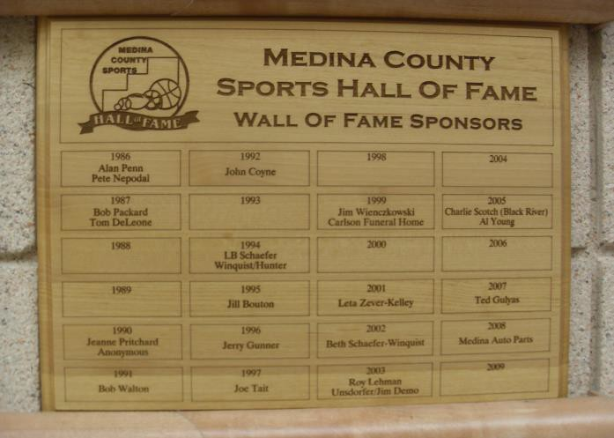

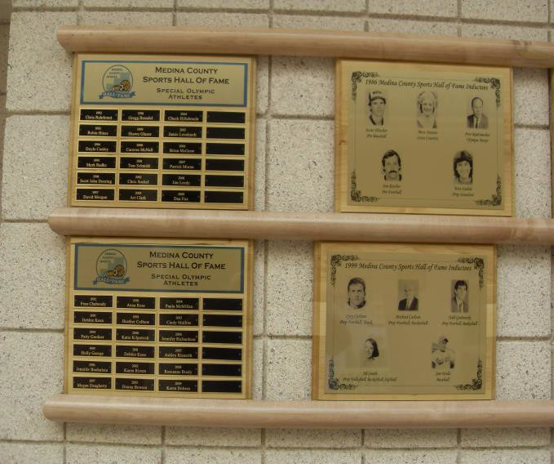

**Medina County Sports Hall of Fame**

**(at the Medina Community Recreation Center)**

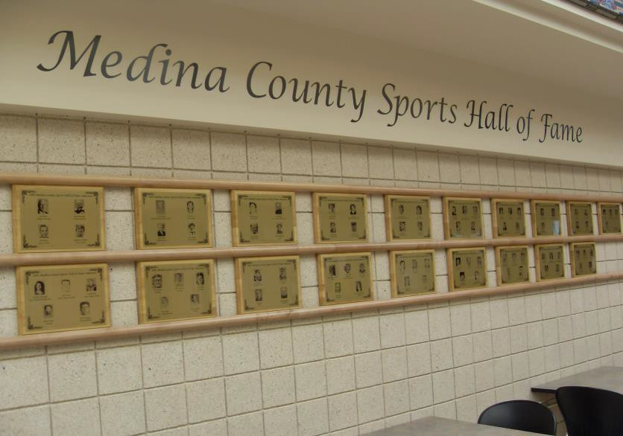

**Consider Joining Medina Breakfast Kiwanis Club, one of Medina’s premier community service organizations**

#### We were formed in 1972 and celebrated our 50 years of service to Medina in September of 2022

We have contributed over $1,450,000 in support of community projects while providing over 1,000,000 hours of service.

If you would like to be a part of a vibrant and very active community service club, you should consider joining us.

We meet the 1st, 2nd and 4th Thursday at the Grande Café and Roastery. Our meetings begin at 7 am and we are finished by 8 am

For more information contact our club at [info@kiwanisbreakfast.com](mailto:info@kiwanisbreakfast.com) to join our meeting



**MEDINA BREAKFAST KIWANIS SPORTS HALL OF FAME COMMITTEE ANNOUNCES**



**GRANTS TO BE GIVEN TO COMMUNITY ORGANIZATIONS**

The Medina Breakfast Kiwanis Club Board of Directors will meet in August to review grant requests from community organizations.

The grants are for the use of funds generated from the annual Medina County Sports Hall of Fame event.

The focus of grants funded is on organizations that support children and families in Medina County.

Our Breakfast Kiwanis Club has given out over $150,000 in grants to community organizations since the beginning of this grant program.

Grant applications will be available July 15th. Contact Alan Penn at [alanpenn99@gmail.com](mailto:alanpenn99@gmail.com) for an application.

